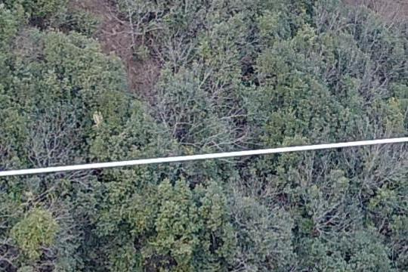  LAT: 40.83985924  LONG: -81.31279218 | 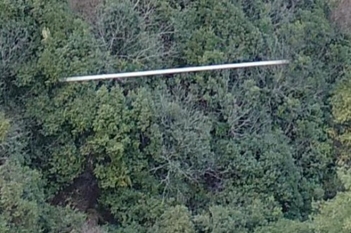  LAT: 40.86513346  LONG: -81.36443258
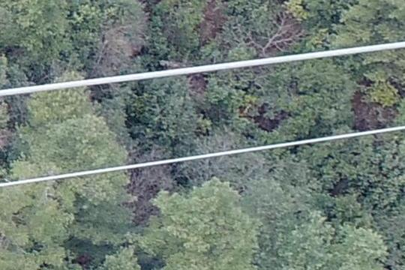  LAT: 40.72985477  LONG: -81.52852817 | 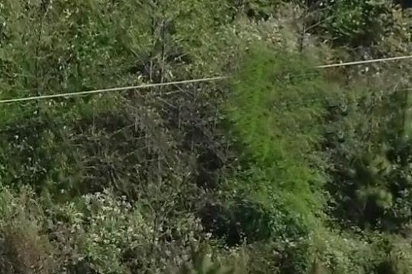  LAT: 40.84190447  LONG: -81.34527799
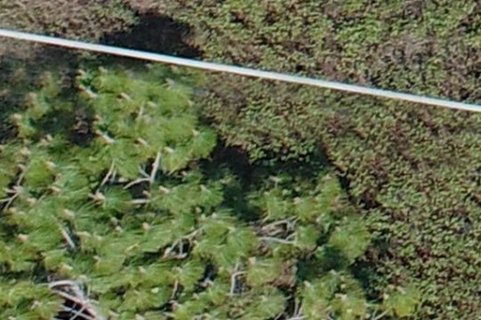  LAT: 40.78040051  LONG: -81.40385244 | 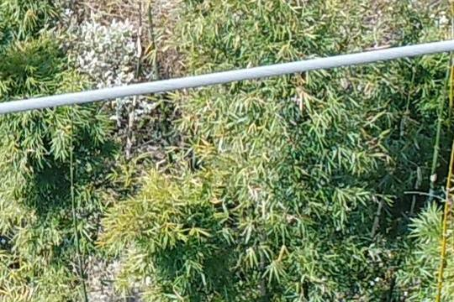  LAT: 40.78007088  LONG: -81.40176948
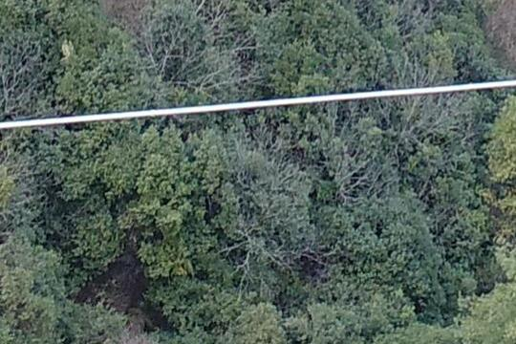  LAT: 39.45048916  LONG: -89.47582910 | 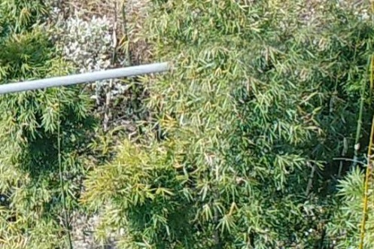  LAT: 49.48841541  LONG: -81.47465700
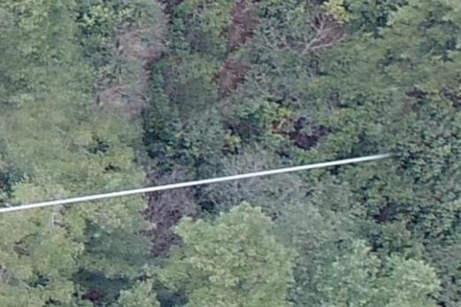  LAT: 42.15452273  LONG: -87.85701499 | 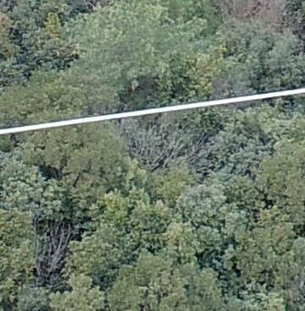  LAT: 40.75661631  LONG: -81.52482950
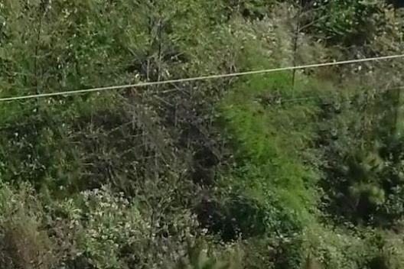  LAT: 40.77789167  LONG: -81.40479050 | 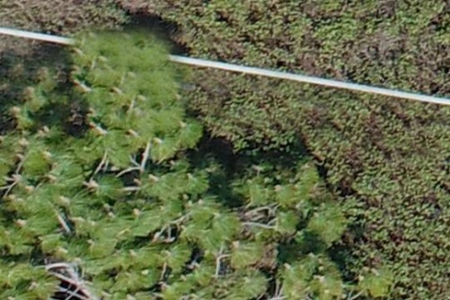  LAT: 40.79737014  LONG: -81.40479050
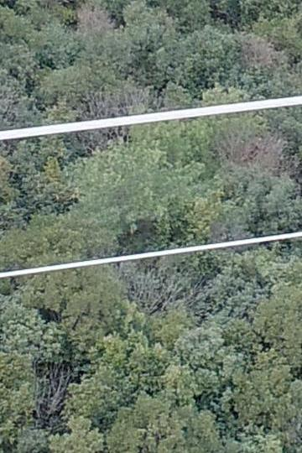  LAT:  LONG: | 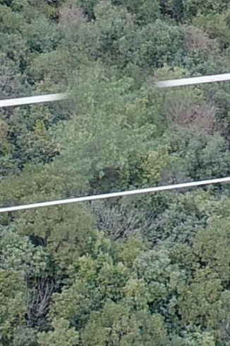  LAT:  LONG:

